**Operating System Lab**

**Fall 2024**

**Lab 05 Task**



**Name: Samreen Bibi**

**Sap ID: 46484**

**Batch: BSCS 5th semester**

**Lab Instructor:**

**Kausar Nasreen Khattak**

**Lab Task**

**Q1.**

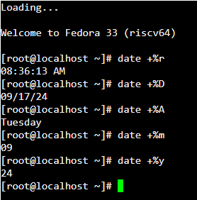

**Q2.**

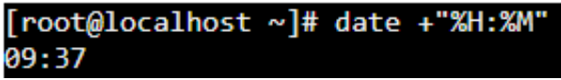

**Q3.**

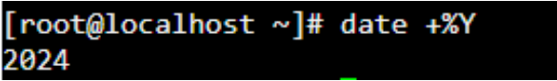

**Q4.**

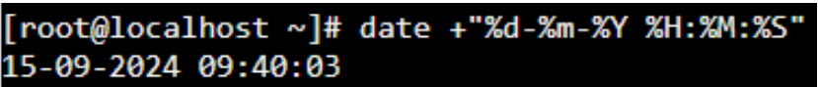

**Q5.**



**Q6.**



**Q7.**



**Q8.**

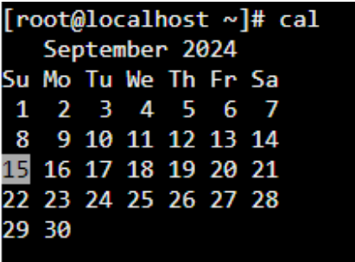

**Q9.**

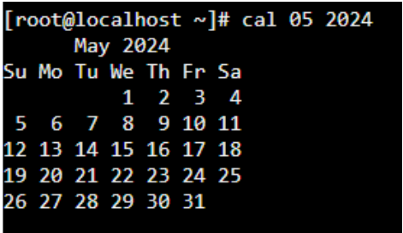

**Q10.**

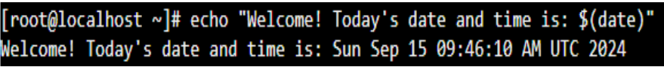

**2.**

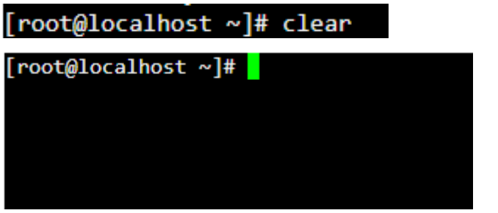

**Q11.**

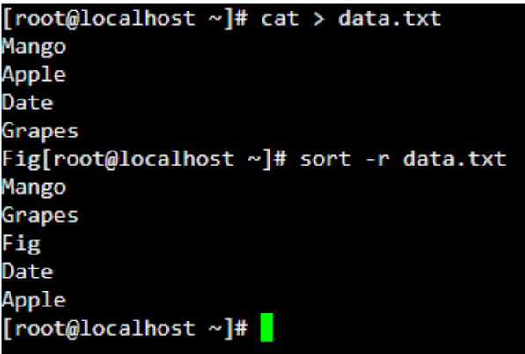

**(B)**



